CALCULATION AND VERIFICATION OF FREQUENCY DEVIATION AND MODULATION INDEX OF FM SIGNALS USING MATLAB SIMULATION
Analog and Digital Communication — Experiment 7
Date of Experiment | 12/10/2026
Performed By | Lokesh A
Register Number | 192512293
1. Aim
To calculate and verify the frequency deviation and modulation index of a Frequency Modulated (FM) signal using MATLAB, and to plot the message signal and FM signal.
2. MATLAB Program
% Calculation and Verification of Frequency Deviation
% and Modulation Index of FM Signal
clc;
clear;
close all;
%% Message Signal Parameters
Am = 2; % Message amplitude (V)
fm = 500; % Message frequency (Hz)
%% Carrier Signal Parameters
Ac = 1; % Carrier amplitude (V)
fc = 10000; % Carrier frequency (Hz)
%% FM Parameters
kf = 250; % Frequency sensitivity (Hz/V)
fs = 100000; % Sampling frequency (Hz)
T = 0.01; % Simulation duration (s)
%% Time Vector
t = 0:1/fs:T;
%% Message Signal
m = Am*cos(2*pi*fm*t);
%% Frequency Deviation
delta_f = kf*Am;
%% Modulation Index
beta = delta_f/fm;
%% FM Signal
fm_signal = Ac*cos(2*pi*fc*t + beta*sin(2*pi*fm*t));
%% Display Parameters
fprintf('Carrier Frequency (fc) = %.0f Hz\n',fc);
fprintf('Message Frequency (fm) = %.0f Hz\n',fm);
fprintf('Message Amplitude (Am) = %.0f V\n',Am);
fprintf('Frequency Sensitivity (kf) = %.0f Hz/V\n',kf);
fprintf('\nFrequency Deviation (Delta f) = %.2f Hz\n',delta_f);
fprintf('Modulation Index (Beta) = %.2f\n',beta);
%% Verification
beta_verify = delta_f/fm;
fprintf('Verified Modulation Index = %.2f\n',beta_verify);
%% Verification Check
tolerance = 1e-6;
if abs(beta - beta_verify) < tolerance
fprintf('\nVerification Successful\n');
else
fprintf('\nVerification Failed\n');
end
%% Plotting
figure;
subplot(2,1,1);
plot(t,m,'LineWidth',1.5);
grid on;
title('Message Signal');
xlabel('Time (s)');
ylabel('Amplitude (V)');
subplot(2,1,2);
plot(t,fm_signal,'LineWidth',1);
grid on;
title('FM Signal');
xlabel('Time (s)');
ylabel('Amplitude (V)');
3. Output
The MATLAB output displays the message signal and FM signal. The Command Window reports the carrier frequency, message frequency, message amplitude, frequency sensitivity, calculated frequency deviation, modulation index and verification result.
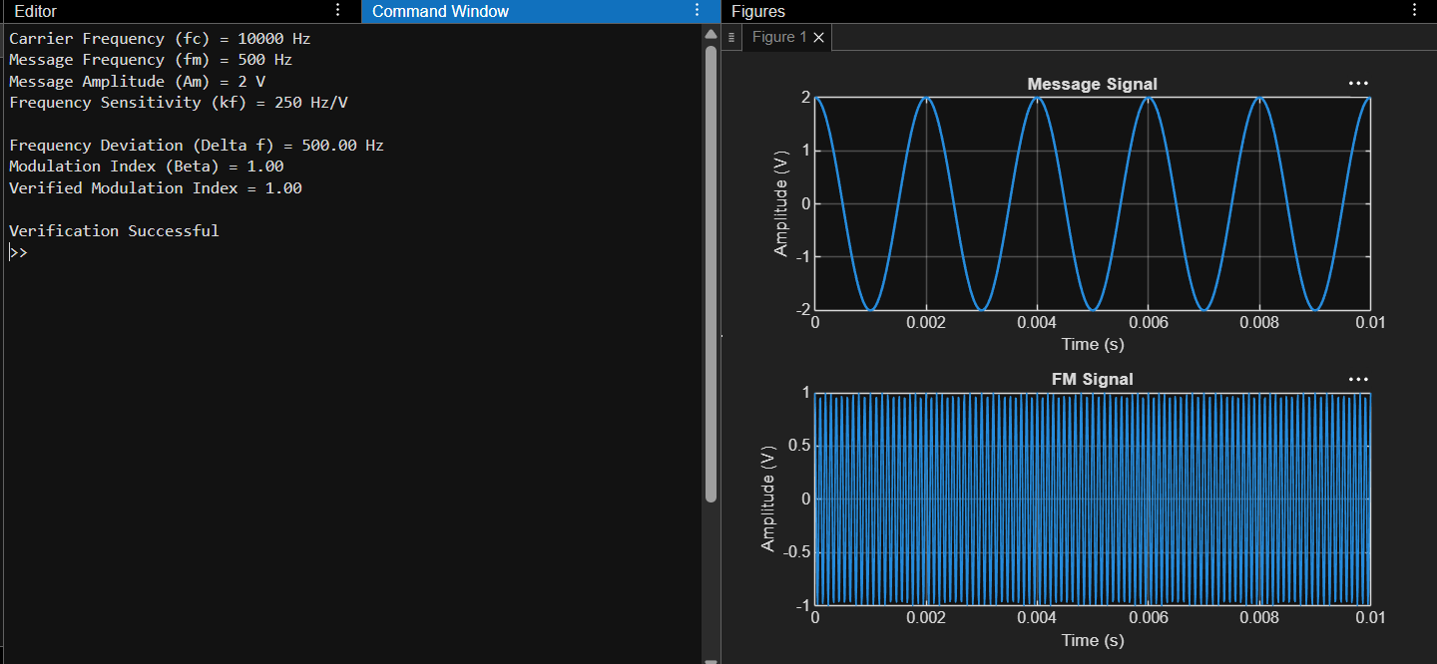
Figure 1. MATLAB plots of the message signal and FM signal.
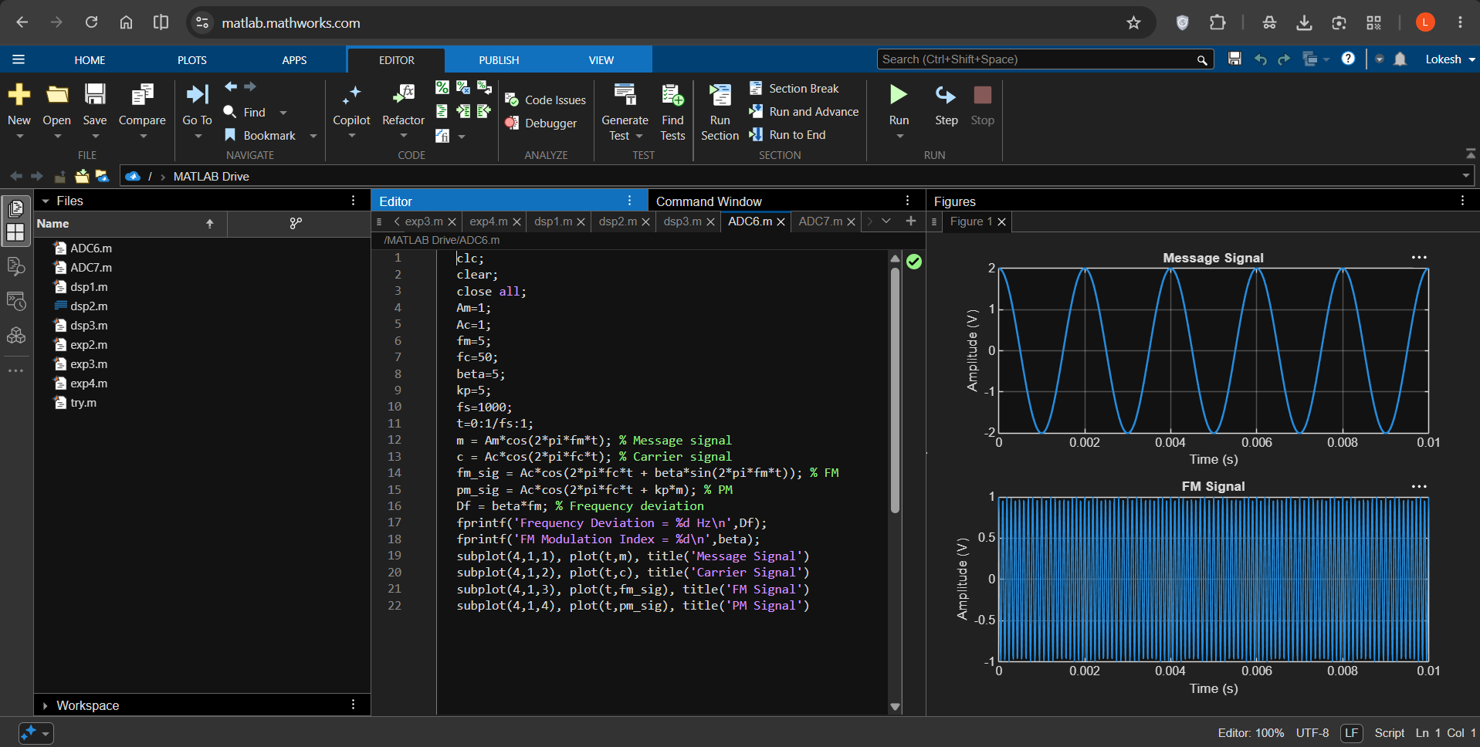
Figure 2. MATLAB Command Window showing the calculated parameters and successful verification.
4. Calculated Results
Parameter | Value
Message amplitude (Am) | 2 V
Message frequency (fm) | 500 Hz
Carrier amplitude (Ac) | 1 V
Carrier frequency (fc) | 10,000 Hz
Frequency sensitivity (kf) | 250 Hz/V
Frequency deviation (Δf = kf × Am) | 500 Hz
FM modulation index (β = Δf / fm) | 1.00
Verified modulation index | 1.00
Verification status | Successful
5. Applications
- FM radio broadcasting and audio transmission.
- Wireless communication systems that encode information through carrier-frequency variation.
- FM telemetry and monitoring systems that transmit measurement information.
- Communication laboratories for verifying frequency deviation and modulation index.
6. Alignment with Analog and Digital Communication
This experiment directly demonstrates frequency modulation, frequency deviation and FM modulation index, which are fundamental parameters in angle modulation. MATLAB is used to generate the message and FM waveforms and verify the numerical relationship β = Δf / fm.
ADC Concept | Implementation | Observed Result
Message signal | Am = 2 V and fm = 500 Hz | Message Signal plot
Carrier signal | Ac = 1 V and fc = 10 kHz | Carrier used in FM generation
Frequency deviation | Δf = kf × Am | 500 Hz
FM modulation index | β = Δf / fm | 1.00
Verification | Compare calculated and verified β values | Verification Successful
FM waveform | Phase term includes β sin(2πfmt) | FM Signal plot
7. Justification
- The experiment calculates frequency deviation from frequency sensitivity and message amplitude.
- The modulation index is determined using the ratio of frequency deviation to message frequency.
- An independent verification calculation checks the modulation-index result.
- The message and FM plots visually demonstrate the signals used in the simulation.
- The Command Window output provides numerical evidence that the calculated and verified modulation indices agree.
8. Conclusion
The frequency deviation and modulation index of the FM signal were calculated and verified using MATLAB. For the given parameters, the frequency deviation is 500 Hz and the modulation index is 1.00. The verification check was successful, and the message and FM waveforms were plotted.
DONE BY
Lokesh A
Register Number: 192512293
B.E. Electronics and Communication Engineering (ECE)

